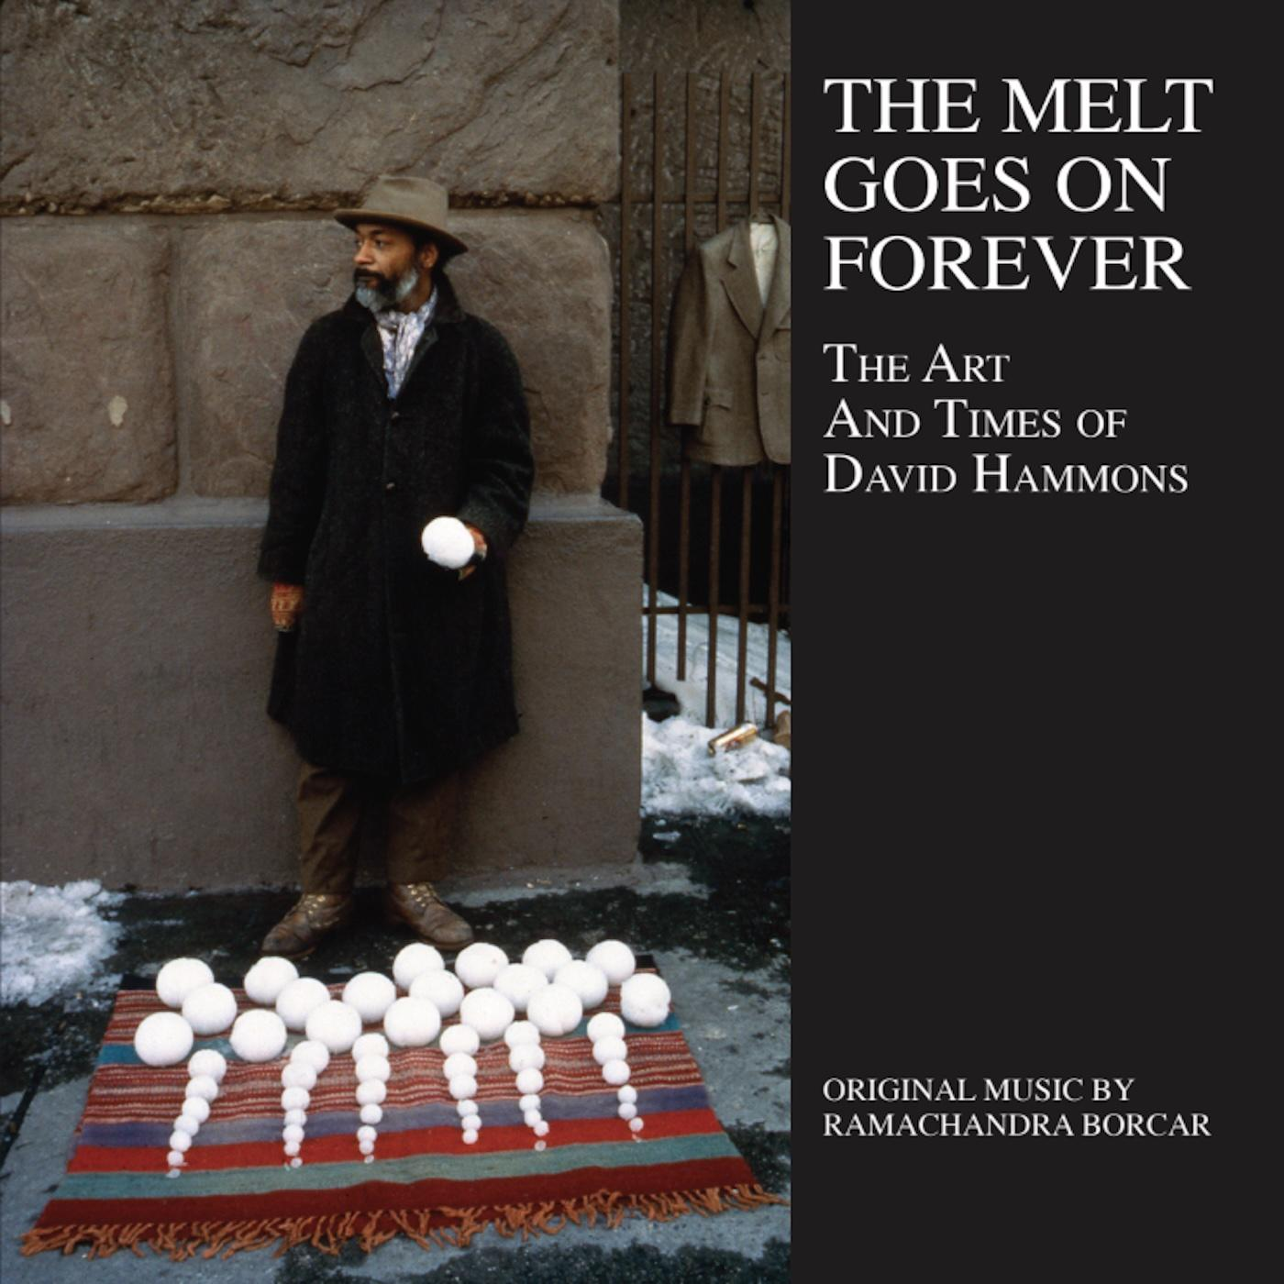
Artist: Ramachandra Borcar
Title: The Melt Goes On Forever: The Art And Times Of David Hammons
Format: Vinyl LP / CD / Digital
Label: Strut
Release Date: 29th January 2027

Strut presents a major release for 2027 celebrating the expanded original score from The Melt Goes On Forever, the critically acclaimed documentary exploring the life, art and times of American outsider artist David Hammons. Created by award-winning film composer and avid record collector Ramachandra Borcar, the album – which also includes new material that does not appear in the film – features an extraordinary guest line up of jazz and avant-garde greats including Shabaka Hutchings, Marshall Allen (Sun Ra Arkestra), The Pyramids’ Idris Ackamoor, Ethio-jazz pioneer Mulatu Astatke, Umar Bin Hassan (The Last Poets), Kibrom Birhane, Jamael Dean and Richard White (The Besnard Lakes).

David Hammons, revered as a visionary artist of his time, spent his career exploring the Black American experience through an ever-evolving range of forms and techniques. Working across sculpture, performance, drawing, video and body prints, Hammons rose to prominence in the early 1970’s and has continued to the present day, all the while remaining one of America’s most influential and enigmatic artists.

Ramachandra Borcar has established his distinctive voice through boundary-defying film scores that span experimental electronics, atmospheric jazz, orchestral composition and global music. The son of an Indian father and Danish mother, and raised in Montreal, Ram’s eclectic musical sensibility was shaped by his unique upbringing, his early years in the city’s underground punk and metal scene, and his studies in classical composition, jazz arranging and percussion performance. Having relocated to Los Angeles, Ram has continued to cultivate an impressive roster of creative collaborations with filmmakers and artists from around the world. His work on The Melt Goes On Forever – which earned the prestigious IDA Award for Best Original Score – reflects this singular musical perspective, drawing on a lifetime of exploration across genres and sonic possibilities.

Deeply inspired by Hammons’ artistic process, Ramachandra created his score as a musical representation of the iconic work seen in the film. Drawing from Hammons’ love of jazz, his influences from across the African diaspora and his unconventional use of found objects, Ram reflects this approach by combining a hypnotic spiritual jazz sound with a variety of African musical instruments and styles. The inspiration was further tied together with a vast array of found objects used as both percussion and melodic instruments alongside amplified kalimbas, vintage synthesizers and dub-inspired effects. The curated roster of legendary musicians performing on the score are all veterans of the Afro-jazz landscape and represent both the rich musical legacy of the past, and today’s new wave of modern jazz voices.

This definitive soundtrack package presents expanded versions of the film cues alongside previously unreleased material in a fluid and expansive journey through cross-generational jazz, dub and global influences.

The Melt Goes On Forever is available on gatefold Vinyl LP with download card (featuring bonus material), and on CD housed in a deluxe sleeve. Both formats are accompanied by a 28-page booklet tracing the career and unique work of David Hammons through extensive liner notes and rare photos.

Tracklist:
Vinyl LP (+ Download)
A1. The Melt Goes On Forever - Ft. Idris Ackamoor / A2. Last Train To Kinshasa – Part 1 - Ft. Shabaka Hutchings / A3. Body Prints / A4. The Flag Was Red, Black And Green - Ft. Shabaka Hutchings / A5. Flash Of The Spirit - Ft. Umar Bin Hassan, Marshall Allen / B1. Afro Asian Eclipse / B2. Fur Coats: Two Minks, A Fox, A Sable And A Wolf - Ft. Shabaka Hutchings / B3. Basketball And Kool-Aid Download Only*: 1. Injustice Case* / 2. He Wore His Tribe - Ft. Kibrom Birhane* / 3. Flight Fantasy* / 4. Last Train To Kinshasa – Part 2 - Ft. Shabaka Hutchings* / 5. Fur Coats (The "Burnt Fur" Rework) - Ft. Mulatu Astatke*
CD / Digital
1. The Melt Goes On Forever - Ft. Idris Ackamoor / 2. Last Train To Kinshasa – Part 1 - Ft. Shabaka Hutchings / 3. Body Prints / 4. Injustice Case / 5. The Flag Was Red, Black And Green - Ft. Shabaka Hutchings / 6. Flash Of The Spirit - Ft. Umar Bin Hassan, Marshall Allen / 7. He Wore His Tribe - Ft. Kibrom Birhane / 8. Afro Asian Eclipse / 9. Flight Fantasy / 10. Fur Coats: Two Minks, A Fox, A Sable And A Wolf - Ft. Shabaka Hutchings / 11. Last Train To Kinshasa – Part 2 - Ft. Shabaka Hutchings / 12. Basketball And Kool-Aid / 13. Fur Coats (The "Burnt Fur" Rework) - Ft. Mulatu Astatke
www.strut-records.co.uk

