
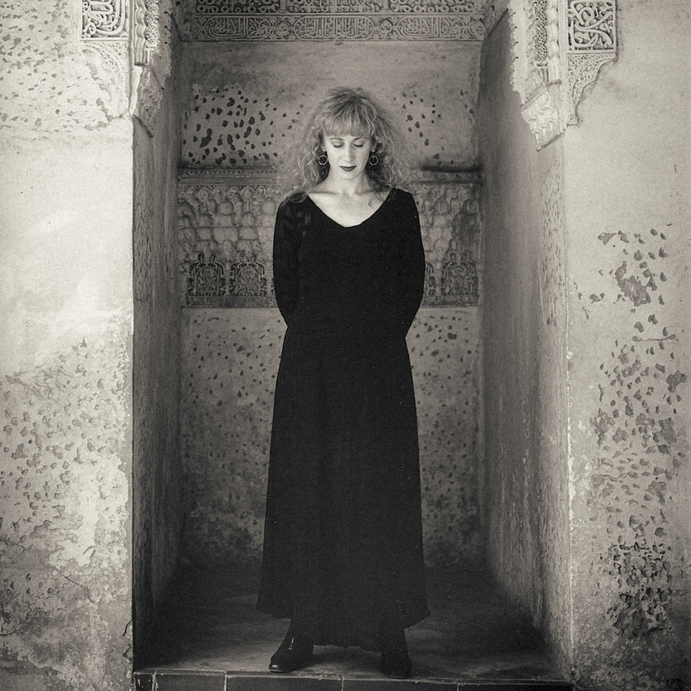
Loreena McKennitt Releases 30th Anniversary Recordings, Launches Upcoming Tour Dates
Exclusive deluxe limited edition of The Mask and the Mirror celebrated with Canadian and European tour dates

STRATFORD, ON – Internationally award-winning Canadian singer-songwriter Loreena McKennitt will release The Mask and Mirror Definitive Edition on Oct. 9, 2026, celebrating the original 1994 edition by sharing exclusive, previously unreleased material. The new deluxe limited edition, available for pre-order now, provides a rich listening experience and invites listeners to delve deeply into this seminal work, which shines new light on a major turning point in McKennitt’s multi-platinum career. The launch is being celebrated with a two-continent tour – in Canada this fall and in Europe the spring of 2027.

The Mask and Mirror was McKennitt’s fifth studio album, praised for its evocative mix of Spanish, Celtic and Moroccan influences and a unique musical palette of instruments, which includes cello, uillean pipes, doumbek, tabla and oud. It transcends genres, layering the artist’s exquisite voice with a multitude of sonic textures, evoking melodic images of other times and other places. The album luxuriates in extended song structures; the LA Times described it as “music full of sombre depths, spiritual longings and age-old echoes.”

The Mask and Mirror Definitive Edition is a four-disc set, mastered by three-time JUNO Award-winner Jeff Wolpert of Desert Fish in Toronto. The set includes two CDs, a DVD and an audio Blu-ray, all housed in a deluxe hard-back book. It contains a 32-page booklet featuring the album’s original artwork, sleeve notes and memorabilia from 1994 and 1995, including photographs, interviews, a dress rehearsal and audio performances, much of it previously unpublished. It also features a four-part personal essay narrated by McKennitt, where she reflects on the travels that inspired the songs, the album’s unique recording circumstances, the international tour that followed and what it all means to her now. The package was designed by GRAMMY® Award-winner Jeri Heiden, of SMOG Design, Inc., Los Angeles. The new release is the second installment in an on-going series of definitive editions celebrating the highlights of McKennitt’s recording career to date; The Visit Definitive Edition was released in 2021.

McKennitt acknowledges the personal relevance of The Mask and Mirror in her distinguished, decades-long career. “By curating and sharing this new edition with collectors and enthusiasts to celebrate the 30th anniversary of our original release, I am inviting the faithful, the curious, and hopefully a new generation of listeners to accompany me into the music and the stories behind the songs in a quest to find the lessons, the commonalities and universal experiences we all share.”

The anniversary tour kicks off in Moncton, NB on Oct. 13 and wraps up Nov. 2 in Montréal, with 13 eastern Canadian cities on the tour schedule. The 30-concert, nine-country European tour will launch next spring, with performances beginning Feb. 22 and concluding on Apr. 3. Many of the concert dates are already sold out or close to being sold out.

About Loreena McKennitt

Loreena McKennitt’s eclectic Celtic blend of pop, folk and world music has resulted in sales of more than 16 million albums worldwide. Her recordings have achieved Gold, Platinum and multi-Platinum status in 15 countries over four continents. She is a two-time GRAMMY® Award nominee, a two-time JUNO Award winner, and a Billboard International Achievement Award winner. She has performed in some of the world’s most storied and historic concert venues, including Carnegie Hall in New York, the Royal Albert Hall in London, the Alhambra Palace in Granada, Spain and the Acropolis in Athens, Greece. She has performed for dignitaries worldwide including the late Queen Elizabeth II, His Majesty King Charles III and other heads of state. Recent honours include promotion from Member of the Order of Canada (2004) to Officer of the Order of Canada (2026), promotion from Chevalier to Officier L’Ordre des Arts et Lettres in France (2026), and her inductions into the Canadian Songwriters’ Hall of Fame (2023) and Canadian Music Hall of Fame (2025).

themaskandmirror.com

