Jean-Michel Blais Shares New Single ‘mirador’

Title Track From Forthcoming Album ‘mirador’

Released 25th September on Mercury KX
LISTEN HERE

Credit: Adrian Villagomez
Today, Montreal pianist and composer Jean-Michel Blais shares ‘mirador’, the title track from his forthcoming fourth album, released 25th September on Mercury KX.
Following ‘ulysse’ and ‘carnavalito’, ‘mirador’ brings Blais to the heart of a record shaped by childhood, imagination and the places we create in order to look out onto the world. Hauntingly beautiful, the piece begins with the pulse and breath of a choir before Blais’ piano slowly emerges, its gentle melody surrounded by voices that gather, dissolve and gather again.
The title track takes its name from the imaginary lookout Blais created for himself as a child in his parents’ basement in Nicolet, Québec. As a musical kid and, even if he wasn’t fully aware of these things yet, as a queer person with Tourette’s, this private world became a place of refuge and possibility: somewhere from which he could dream of everything that might exist beyond it.
On ‘mirador’, Blais returns to that lookout from the other side of childhood. What was once solitary becomes collective, with piano and human voices moving around one another until they finally converge on a single triad. It captures something central to the album itself: memory not as something fixed, but something that can be revisited, rearranged and shared.
Speaking about ‘mirador’, Blais says:
“mirador is at the same time the title of the album and of this single. It’s a Spanish word, with ‘mira’ meaning ‘to look’. So, a ‘mirador’ a lookout or a tower from which you protect a castle… mirador for me is this place that as a kid, I would go to travel time and space. I had Tourettes, and as a queer kid I had a hard time, sometimes, to find my way in society. So I would go to the basement, like the one depicted on the album cover, where we had a bunch of VHS, CDs and vinyl, through which I would feel like I could travel the world.”
With more than 375 million streams globally to his name, Blais began mirador by reflecting on childhood memories of building imaginary worlds in his parents’ basement. From there, the record expands far beyond those walls: an odyssey spanning choirs, strings and the music of the Andes, travelling from Spanish caves to Estonian forests and eventually finding its way home to Québec.
Working with composer and arranger William Brittelle (LA Philharmonic, The National), Blais assembled a choir of 12 baroque singers before adding a string quartet of friends. He also enlisted Tulio Velazco Villagra, a master of Andean instruments, while residencies at the Arvo Pärt Centre informed the album’s meditative atmosphere.
The result is Blais’ most adventurous and transportive work yet, exchanging contemporary minimalism for a light and generous maximalism while retaining the intimacy that has always sat at the centre of his music. If the childhood mirador was somewhere Blais could retreat to and imagine the world beyond him, the album that bears its name finds him opening that space up: looking backwards, outwards and towards the future.

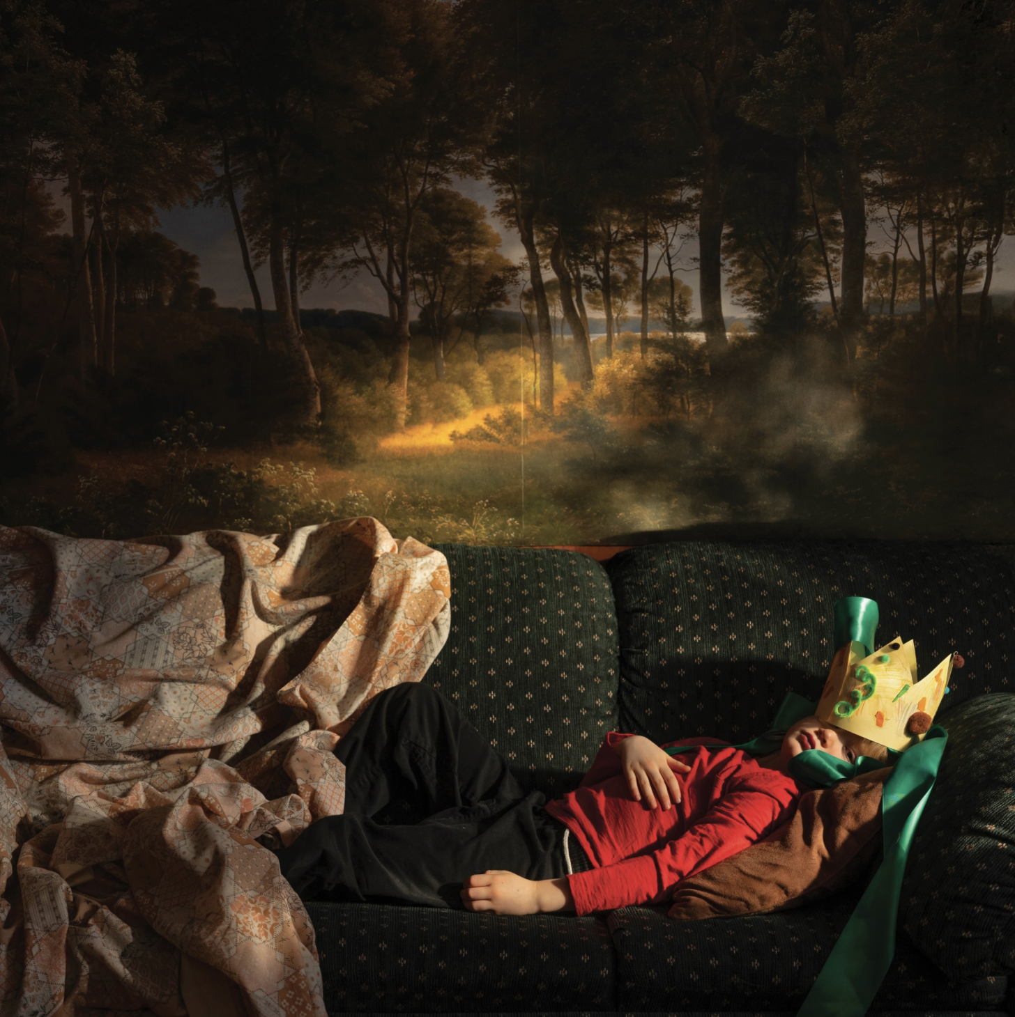
‘mirador’ artwork

Tracklisting
muses
ulysse
pavane
carnavalito
mirador
quwi
granada
kyrie
laulasmaa
silhouettes
querelle
a chambre des possibles

JEAN-MICHEL BLAIS PLAYS:
2026
09.24 — WATERLOO, QC — Maison de la culture de Waterloo
09.27 — STE-GENEVIÈVE, QC — Salle Pauline Julien
10.03 — VAL-MORIN, QC — Théâtre du Marais
10.23 — BERLIN, DE — Felt Room
10.26 — LONDON, UK — World Heart Beat
10.27 — UTRECHT, NL — TivoliVredenburg
10.28 — PARIS, FR — La Piccola Scala
11.28 — TORONTO, ON — Koerner Hall
2027
01.23 — NOMININGUE, QC — Espace Saint-Ignace
01.28 — SAINTE-THÉRÈSE, QC — Théâtre Lionel Groulx
01.29 — ST-HYACINTHE, QC — Centre des arts Juliette Lassonde
01.30 — BAIE-DU-FEBVRE, QC — Théâtre Belcourt
01.31 — VICTORIAVILLE, QC — Le Carré 150
02.05 — SHAWINIGAN, QC — Centre des Arts
02.06 — SHERBROOKE, QC — Théâtre Granada
02.07 — SALABERRY-DE-VALLEYFIELD, QC — Salle Albert Dumouchel
02.10 — DRUMMONDVILLE, QC — Maison des arts Desjardins Drummondville
02.12 — JOLIETTE, QC — Centre Culturel Desjardins
02.13 — MONTMAGNY, QC — Salle Edwin-Bélanger
02.14 — QUÉBEC, QC — Grand Théâtre de Québec
02.17 — BROSSARD, QC — Théâtre Manuvie
02.18 — L’ASSOMPTION, QC — Théâtre Hector Charland
02.19 — ST-MARIE-DE-BEAUCE, QC — Salle Méchatigan
02.20 — THETFORD MINES, QC — Salle Dussault
02.21 — TERREBONNE, QC — Théâtre du Vieux-Terrebonne
02.25 — LONGUEUIL, QC — Théâtre de la Ville
02.26 — LAVAL, QC — Salle André-Mathieu
02.27 — ST-EUSTACHE, QC — Le Zénith
03.05 — OTTAWA, ON — National Arts Centre
04.30 — VANCOUVER, BC — Chan Centre for the Performing Arts
05.20 — EDMUNDSTON, NB — Salle Léo-Poulin
05.21 — CARAQUET, NB — Centre Culturel de Caraquet
05.22 — MONCTON, NB — Capitol Theatre
10.01 — BROMONT, QC — Espace Culturel St-John
10.02 — CHÂTEAUGUAY, QC — Château Scènes
10.03 — LÉVIS, QC — L’Anglicane
10.07 — ST-JEAN-SUR-RICHELIEU, QC — Théâtre des Deux-Rives
10.08 — MONTRÉAL (LASALLE), QC — Théâtre Desjardins
10.10 — GATINEAU, QC — Salle Odyssée
10.12 — ST-JÉRÔME, QC — Théâtre Gilles Vigneault
10.13 — VAL-D’OR, QC — Théâtre Télébec
10.14 — ROUYN-NORANDA, QC — Théâtre du Cuivre
10.15 — AMOS, QC — Théâtre des Eskers
10.19 — TROIS RIVIÈRES, QC Salle J.-Antonio-Thompson
10.20 — SAGUENAY, QC — Théâtre C
10.21 — RIMOUSKI, QC — Salle de Spectacles Desjardins
10.22 — CARLETON-SUR-MER, QC — Studio du Quai des Arts

ABOUT JEAN-MICHEL BLAIS
Jean-Michel Blais is a Montreal based pianist, composer and performer signed to Arts & Crafts and Mercury KX (Decca). In the first decade since the release of his landmark 2016 debut album, II, the classically trained Blais has defined his music through the reverent intimacy he shares with his instrument, the piano. Named in TIME’s Top 10 Best Albums of the Year, the magazine described his improvisation inspired debut as “music that breathes, invites one to take a moment, and acknowledges that there is still much beauty in the world.”
Through this connection with the piano, the multiple Polaris Music Prize shortlisted and two time Juno nominated artist has reached audiences around the world. He has performed one of the largest neoclassical concerts in history to nearly 40,000 people at the Montreal Jazz Festival, collaborated with the Orchestre de l’Agora and the Orchestre symphonique de Québec, and amassed more than 397 million streams across a catalogue that includes the ambient and new age inspired Dans ma main (2018), which drew influence from the music that soothed his Tourette syndrome as a child, the Félix Award winning aubades (2022), his first exploration of composition for chamber orchestra, and désert (2025), a collaborative album with American harpist Lara Somogyi.
His diverse résumé also encompasses the Cannes Award winning Matthias & Maxime (2019) soundtrack, the twilight inspired serenades EP (2023), and Cascades (2017), created with producer CFCF. Together, these works continue Pitchfork’s observation of the “thrilling synchronization of piano and electronics” that has become a defining thread throughout his catalogue.
On mirador, his fourth studio album, released in September 2026, Blais embarks on an expansive, beneath the surface odyssey spanning choirs, strings and the music of the Andes. Travelling from Spanish caves to Estonian forests before returning home to tiny Nicolet, Québec, mirador opens listeners’ eyes onto Blais’ wide, wondrous and deeply personal world. It is an aspirational journey that exchanges contemporary minimalism for a light, generous maximalism.
Throughout his discography, Blais has used instrumentation and composition as tools of personal expression, subtly revealing different facets of his identity as a queer artist, perpetual traveller, student and caregiver, often through the lens of his upbringing. Four albums into his career, Jean-Michel Blais is no longer simply charting the map of his grown up heart. On mirador, he offers a new perspective on childhood: a vivid and vicarious invitation to listen again, gazing ahead into the imaginary.

