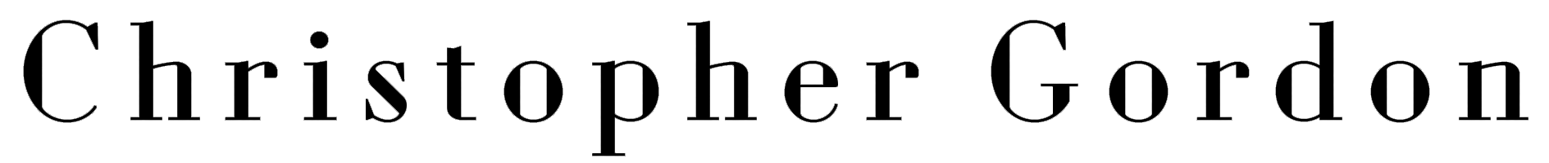
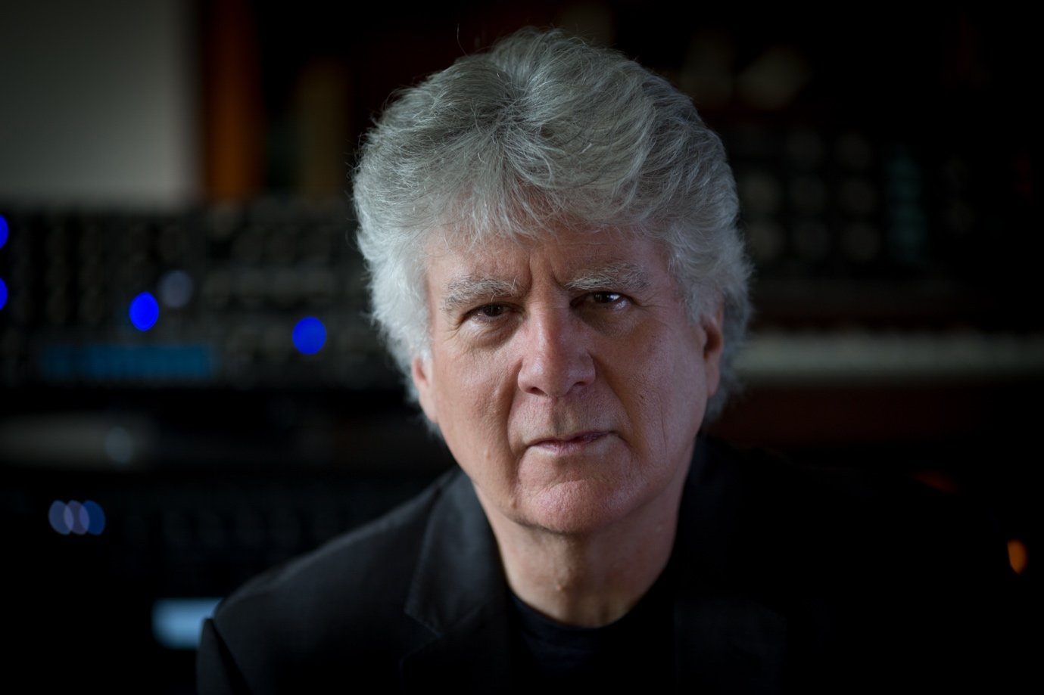

ACCLAIMED COMPOSER CHRISTOPHER GORDON'S POWERFUL NEW INTERPRETATION OF SHAKESPEARE'S MACBETH, PERFORMED BY AN EXCEPTIONAL CAST OF INTERNATIONAL GUESTS, ORCHESTRA AND CHOIR – SET FOR RELEASE ON MADFISH ON 30th OCTOBER

FEATURES GAVIN HARRISON (PORCUPINE TREE, KING CRIMSON), JONAS REINGOLD (THE FLOWER KINGS, STEVE HACKETT), RANDY MCSTINE (STEVEN WILSON), GREG HOWE (PROTOCOL 4, DARWIN), MOHINI DEY (DARWIN), MARCEL COENEN (AYREON), MICHAEL MILLS (TOEHIDER, AYREON), SYDNEY'S MAGIC FIRE ORCHESTRA AND THE ACCLAIMED CANTILLATION CHOIR

Thursday 3rd September - Originally commissioned as a full-length ballet by the Royal New Zealand Ballet and West Australian Ballet, Macbeth is Christopher Gordon's compelling musical response to one of Shakespeare's darkest and most enduring tragedies. Premiered to critical acclaim in 2026, this ambitious work now receives its first standalone album release on Madfish, coming on 30th October. Speaking about the announcement, Christopher shared “It has been an extraordinary and uplifting experience to work with such incredible musicians on this deep epic tale and I am thrilled that the album can finally go out into the world.”

The recording features an extraordinary international cast of musicians, including Gavin Harrison (Porcupine Tree, King Crimson), Jonas Reingold (The Flower Kings, Steve Hackett), Randy McStine (Steven Wilson), Greg Howe (Protocol 4, DarWin), Mohini Dey (DarWin), Marcel Coenen (Ayreon) and Michael Mills (Toehider, Ayreon), joined by Sydney's Magic Fire Orchestra, the acclaimed Cantillation choir, a string octet and distinguished soloists under Gordon's direction.

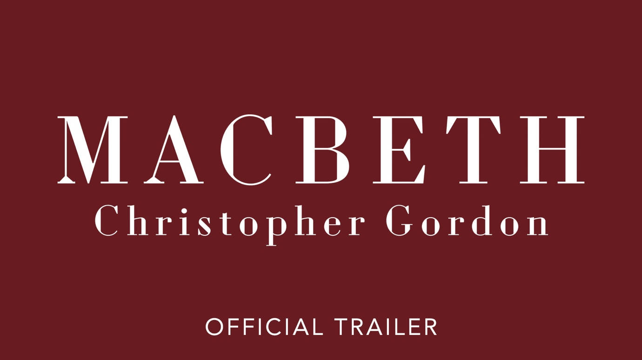
WATCH THE TRAILER FOR CHRISTOPHER GORDON’S ‘MACBETH’

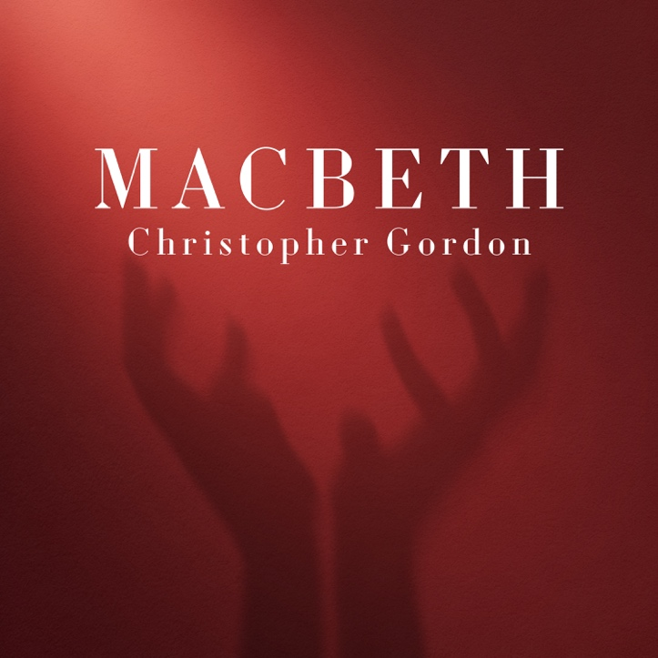

Christopher Gordon - Macbeth
The Battle Lost and Won – 06:23
This Night's Great Business – 05:22
If It Were Done – 06:05
Night's Black Agents – 05:23
The Banquet – 10:51
Something Wicked This Way Comes – 04:47
Out Damned Spot – 03:28
Tomorrow, and Tomorrow, and Tomorrow – 07:53

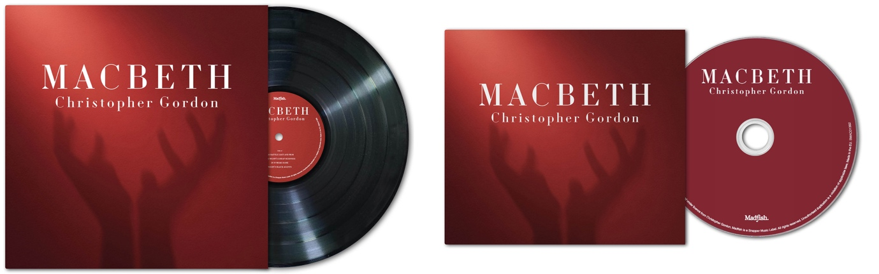
‘MACBETH’ WILL BE RELEASED ON CLASSIC BLACK VINYL LP, DIGIPACK CD WITH 12-PAGE BOOKLET AND DIGITALLY. PRE-ORDER HERE.

Drawing together progressive rock, contemporary orchestral writing and jazz influences into a richly cinematic score, Macbeth traces the psychological descent of its central characters across eight expansive movements. From the ominous opening of 'The Battle Lost and Won' to the haunting finale 'Tomorrow, and Tomorrow, and Tomorrow', Gordon balances moments of immense power with passages of striking intimacy, capturing the tension, ambition and fatalism at the heart of Shakespeare's play.

Recorded and mixed at Sydney's Trackdown Studios, Macbeth presents a suite from Gordon's acclaimed ballet score in a form that stands confidently as a complete listening experience, bringing this remarkable work beyond the stage for the first time.

FOLLOW CHRISTOPHER GORDON
FACEBOOK
YOUTUBE
WEBSITE


www.madfishmusic.com

