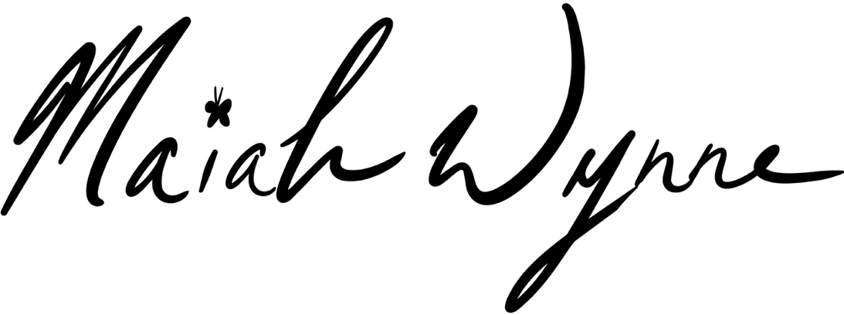
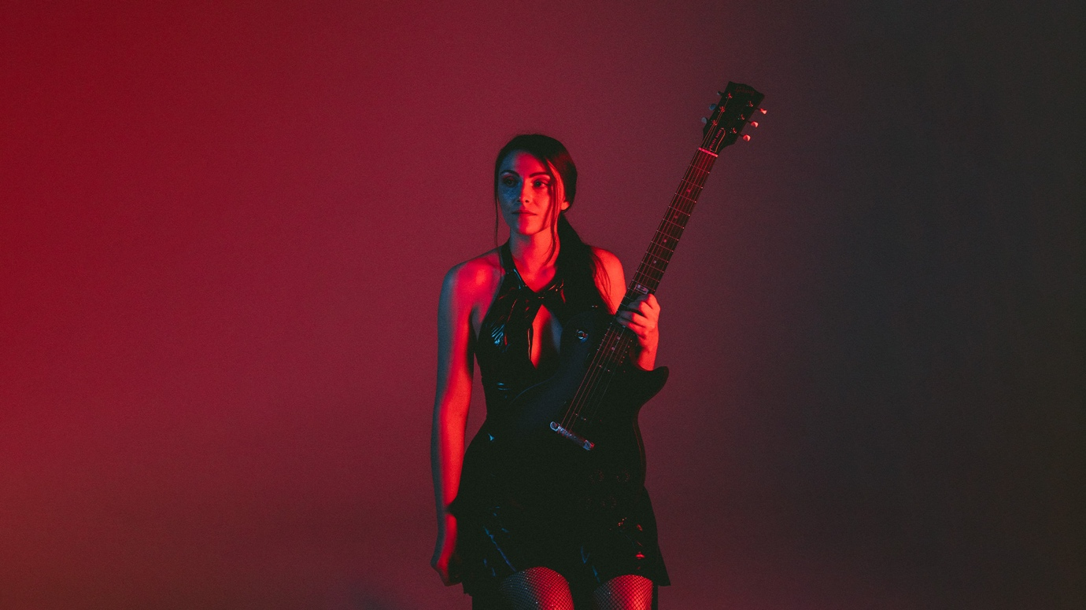
Photo by Digital Sorcery

MAIAH WYNNE ANNOUNCES NEW STUDIO ALBUM
INTO THE WAVES, SET FOR RELEASE ON 25th SEPTEMBER

NEW SINGLE ‘SEE THE WATER’ OUT TODAY

Friday 7th August – Following the news of her signing to Kscope and the release of her single ‘Breathe’ earlier this year, acclaimed singer, songwriter and multi-instrumentalist Maiah Wynne has today announced her new album, Into The Waves, alongside a brand-new single, ‘See The Water’.

“I wrote "See the Water" in a handful of minutes when I was 16. I had just been gifted a dulcimer and found my hands quickly dancing around a folky melody in D minor. What came out was the manifestation of my inner critic. That voice inside my head that always told me I wasn't enough, no matter how hard I tried. I decided to create a character out of her to represent the feeling of being hunted and haunted by that voice everywhere I went. The imagery of water and drowning in those feelings kept coming up and in a moment of quick inspiration, the song came out fully formed and has only changed slightly in the years since. It's nice to finally have a studio version of it out in the world close to how I always pictured it in my head.” - Maiah Wynne

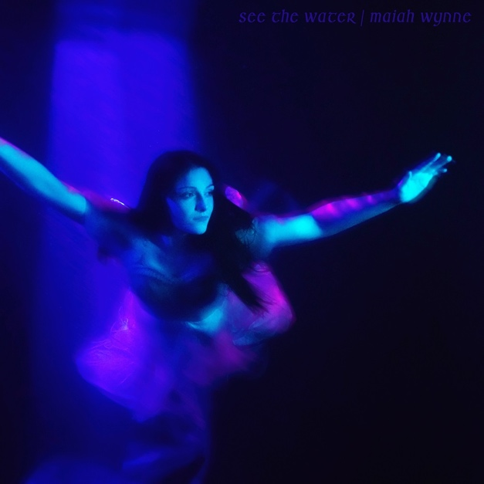
STREAM/DOWNLOAD THE NEW SINGLE ‘SEE THE WATER’

Written, self-produced and largely recorded by Wynne during an exceptionally transformative period in her life, Into the Waves was created between her first international tour, a move across the world, returning to education, and building a new life after years of isolation. Many of the recordings were captured on the road in hotel rooms using nothing more than a laptop, with Wynne playing more than a dozen instruments across the album. The project was completed with mixing and additional production from Justin Abel (Noelle Johnson, The Talbott Brothers) before being mastered by Alan Douches (Sufjan Stevens, Motörhead, LCD Soundsystem).

Into The Waves features an impressive cast of collaborators, including cellist Bethany Joyce, violinist Avelyn Reynolds, guitarist Brooks Berg, drummers Adam Brzycki and Randy Cooke, flugelhorn player Henry Sheppard, and Rush legend Alex Lifeson, whose guest guitar appearance further strengthens the connection between Wynne's solo work and her role as vocalist with Envy of None.

Speaking to Rolling Stone, Lifeson remarked: “I’ve never had that kind of inspiration working with another musician.” Wynne’s new album Into The Waves sees Lifeson contributing to six tracks.

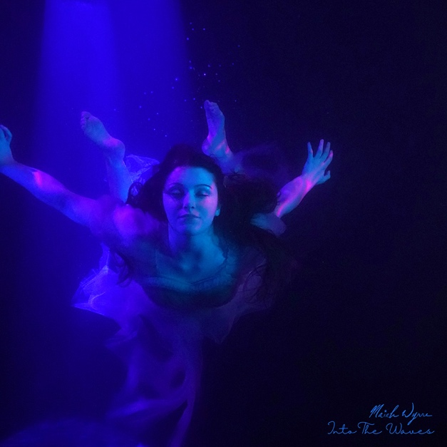

Maiah Wynne - Into The Waves
1. Nothing Stays The Same [04:06]
2. Satellites [03:31]
3. In A Dream [04:03]
4. Creatures In The Night [03:33]
5. False gods [03:25]
6. Another Step (Featuring Dan Avidan) [03:58]
7. See The Water [03:00]
8. Underwater [02:40]
9. Don’t Want To Say Goodbye [04:48]
10. Breathe [02:38]
11. Don’t Wait [04:42]
12. Girl Dinner [04:03]

PRE-ORDER THE NEW ALBUM INTO THE WAVES

INTO THE WAVES WILL BE RELEASED ON THE FOLLOWING FORMATS:

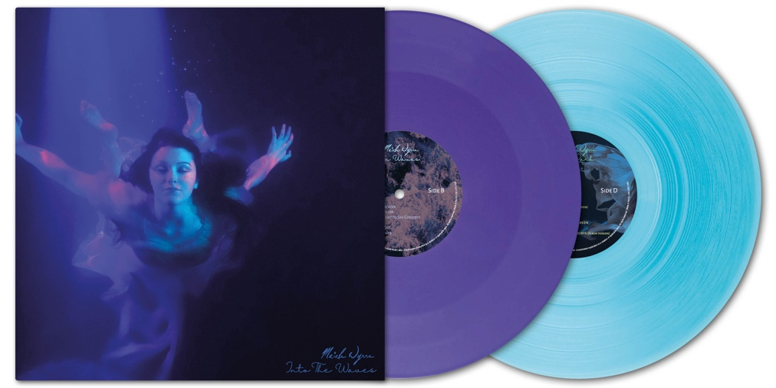
GATEFOLD COMBO 2LP (PURPLE AND TRANSPARENT TURQUOISE VINYL), INCLUDES THE NEW STUDIO ALBUM + 2024’s ALBUM OUT OF THE DARK, FIRST TIME ON VINYL

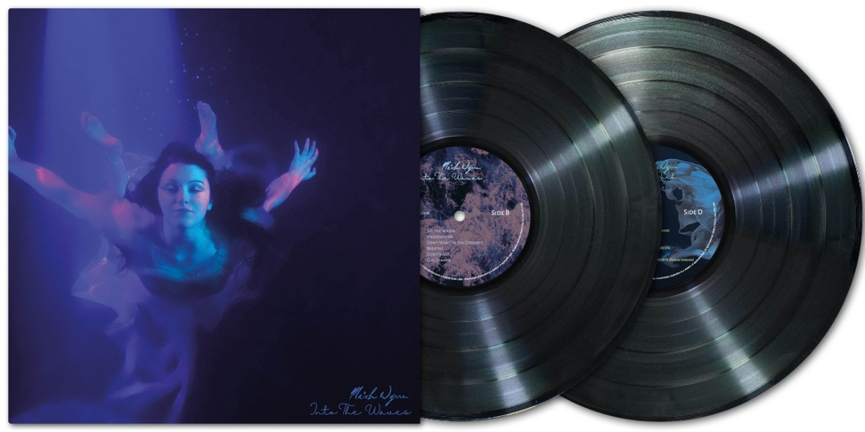
GATEFOLD BLACK VINYL 2LP, INCLUDES THE NEW STUDIO ALBUM AND MAIAH WYNNE’S 2024 ALBUM OUT OF THE DARK, FIRST TIME ON VINYL

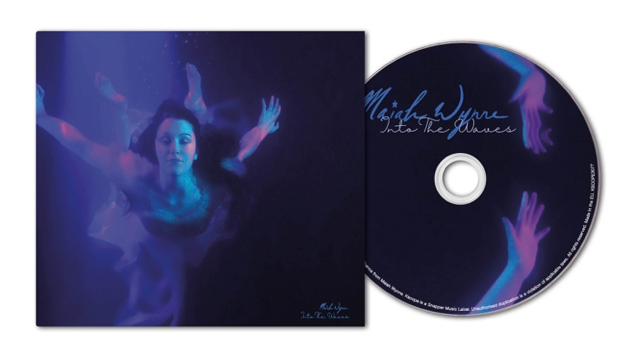
DIGIPACK CD EDITION, INCLUDES 8-PAGE PRINTED BOOKLET

Wynne has previously toured extensively across the United States, sharing stages with artists including Brandi Carlile, Indigo Girls, and Tanya Tucker, and performing at major festivals such as Red Ants Pants and Timber Music Festival. Her music has received coverage from leading publications including Rolling Stone, Billboard, Guitar World, and NPR Music.

Maiah Wynne’s new album Into The Waves will be released on 25th September, pre-orders are now available here.

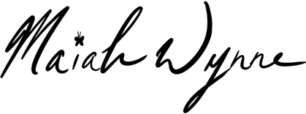
Maiah Wynne website
Facebook
Instagram
YouTube
Spotify
Apple Music
Kscope artist page
Download images


www.kscopemusic.com

