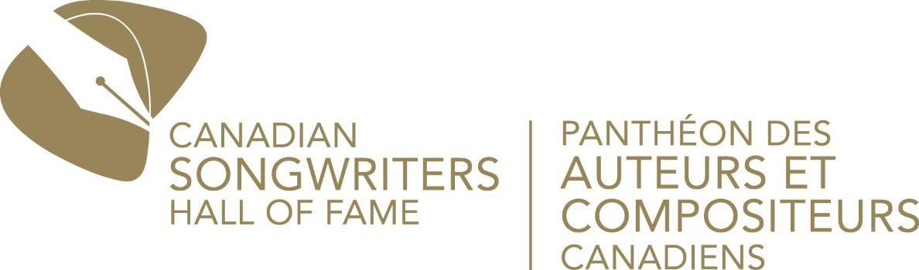

CITY AND COLOUR, FINNEAS, OUR LADY PEACE, AMANDA MARSHALL AND JEFF TWEEDY AMONG PERFORMERS ANNOUNCED FOR 2026 CANADIAN SONGWRITERS HALL OF FAME INDUCTION CEREMONY

George Stroumboulopoulos and Marie-Mai to Host September 26 Celebration at Massey Hall Honouring The Tragically Hip, Mike Reno and Paul Dean of Loverboy, Leslie Feist, and Roch Voisine

Allison Russell, Amanda Marshall, Charlotte Cornfield, Isabelle Boulay, Ludovick Bourgeois, Matt Lang, Ruby Waters, Sara Dufour, Sebastian Gaskin, TALK, Tia Wood, and Todd Kerns Join Newly Announced Performers; Boi-1da to Make Special Appearance; Inductors Include Bruce McCulloch, FINNEAS, Jay Baruchel, Jim Vallance, Laura Stacey, and Marie-Philip Poulin
FOR IMMEDIATE RELEASE: TORONTO, ON – August 25, 2026 – The Canadian Songwriters Hall of Fame has unveiled a powerhouse roster of hosts, performers, and inductors for the 2026 CSHF Induction Ceremony, presented by Amazon Music, at Toronto’s Massey Hall on September 26, 2026. Bringing together international stars and some of Canada’s most exciting emerging voices, the ceremony will honour The Tragically Hip, the band that helped define the sound and spirit of a nation; Mike Reno and Paul Dean, the songwriting partnership that made Loverboy one of Canada’s most successful rock acts; Leslie Feist, whose original and singular voice has shaped contemporary songwriting in Canada and internationally; and Roch Voisine, one of Canada’s most successful bilingual songwriters.
Performers announced today include:
• GRAMMY and JUNO Award-winner Allison Russell
• Diamond-selling vocalist Amanda Marshall
• Polaris shortlisted songwriter Charlotte Cornfield
• Multi-platinum, JUNO Award-winning City and Colour
• Multi GRAMMY Award-winning artist and producer FINNEAS
• Gold and platinum-selling vocalist Isabelle Boulay
• GRAMMY Award-winning songwriter and Wilco frontman Jeff Tweedy
• La Voix winner and Québec pop artist Ludovick Bourgeois
• Two-time Félix Award winning country artist Matt Lang
• Diamond-certified and four-time JUNO-winning rock band Our Lady Peace
• Soulful alternative artist Ruby Waters
• Country rock storyteller Sara Dufour
• JUNO Award-winning singer-songwriter Sebastian Gaskin
• Platinum-selling global sensation TALK
• Rising pop and R&B artist Tia Wood
• Canadian rock veteran and longtime Slash collaborator Todd Kerns
The celebration will also feature a special appearance by GRAMMY Award-winning producer and songwriter Boi-1da. Broadcaster and producer George Stroumboulopoulos and singer, songwriter and television personality Marie-Mai will host.
The 2026 honourees will be inducted by two-time Academy Award-winning songwriter FINNEAS; The Kids in the Hall co-founder Bruce McCulloch; actor and filmmaker Jay Baruchel; internationally renowned songwriting legend and 2022 Canadian Songwriters Hall of Fame inductee Jim Vallance, who holds the record with four JUNO Songwriter of the Year wins; and Olympic gold medalists in women’s hockey Marie-Philip Poulin and Laura Stacey
Additional performers and special guests will be announced in the coming weeks, with more surprises to be revealed on the night of the ceremony.
Tickets for the 2026 Canadian Songwriters Hall of Fame Induction Ceremony can be purchased via the Massey Hall box office at 416-872-4255 or online at www.masseyhall.com.
Presented in collaboration with Amazon Music, the 2026 Induction Ceremony will be live-streamed globally via the Amazon Music Twitch channel and the Amazon Music app. It will also be available to stream on Prime Video in Canada. The livestream will be hosted by two-time Canadian Screen Award winner Keshia Chanté, who will guide viewers through the evening with commentary, songwriter interviews, and additional context celebrating the inductees and their contributions to Canadian music. Fans can also listen to the official Canadian Songwriters Hall of Fame 2026 playlist HERE.

The Canadian Songwriters Hall of Fame gratefully acknowledges the generous support of our sponsors and partners: Amazon Music, SOCAN, RBCxMusic, Barometer Global Music Royalty Fund, Hargraft Insurance, CMRRA, Boucher Guitares, Cassels Brock & Blackwell LLP, Le Germain Hotels, the Songwriters Association of Canada, peermusic, e=mc² Productions, Kawartha Lakes Tourism, and the Lewitt Family Foundation, whose continued support helps us celebrate and champion Canadian songwriters.

Press photos and biographies of the honoured artists, performers, and hosts can be found HERE.

For more information about the Canadian Songwriters Hall of Fame, visit www.cshf.ca.

Media Accreditation is now open. Media are invited to cover the Red-Carpet arrivals and ceremony. Apply for accreditation HERE. The deadline to apply is September 8, 2026.

ABOUT THE CANADIAN SONGWRITERS HALL OF FAME (CSHF)
The Canadian Songwriters Hall of Fame (CSHF) is the nation’s premier institution dedicated to honouring and celebrating Canada’s greatest songwriters. Through its prestigious Induction Ceremony and year-round programming, the CSHF recognizes the creators whose work has shaped Canada’s cultural identity while championing the voices defining its future. As a national, bilingual non-profit, the CSHF connects legendary songwriters with emerging talent through flagship initiatives including LEGENDS, Song & Score Week, and the Breakthrough Songwriter Award, providing mentorship, career development, and industry access. Acquired by SOCAN in 2011, the CSHF operates independently under its own Board of Directors, representing leading Anglophone and Francophone creators and publishers.

ABOUT AMAZON MUSIC
Amazon Music is an immersive audio entertainment service that connects fans, artists, and creators through music, podcasts, and culture. Amazon Music brings fans closer to what they love, with curated and personalized playlists, artist livestreams, artist merch, and Amazon Exclusive podcasts. Prime members get access to millions of songs in shuffle mode, All-Access playlists, plus the largest catalog of ad-free top podcasts, included with their membership. Customers can upgrade to Amazon Music Unlimited for full, on-demand access to millions of songs, as well as millions of songs in HD, Ultra HD, and Spatial audio, and the world’s largest selection of audiobooks from Audible. Anyone can listen to Amazon Music by downloading the free Amazon Music app, or wherever they listen to music, including Alexa-enabled devices. Learn more at amazon.com/music.
-30-
Media Contacts:

TORONTO MONTREAL

Victoria Lord Simon Fauteux
Victoria Lord PR Six Media
E: victoria@vlpr.com P: 647.519.8577 E: simon@sixmedia.ca P: 514.972.4584

