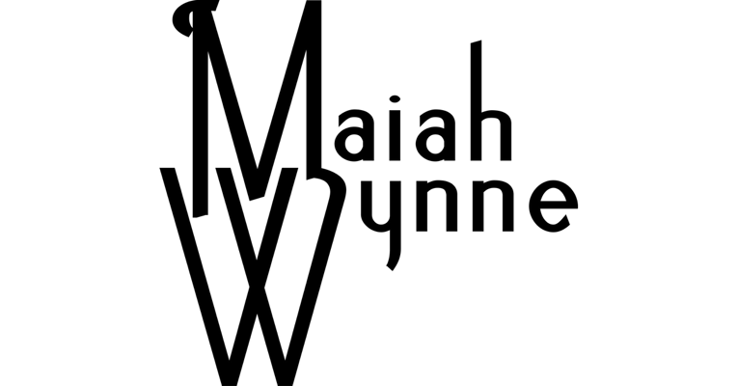

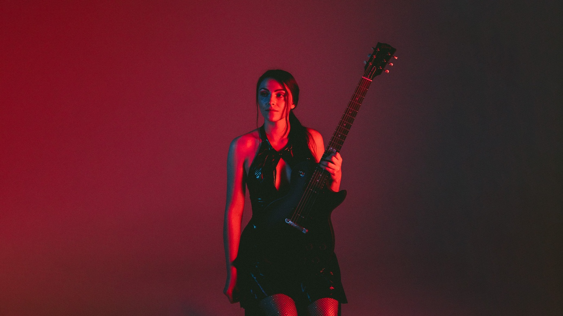

MAIAH WYNNE ARRIVES ON KSCOPE WITH DEBUT SINGLE ‘BREATHE’

NEW ALBUM PENNED FOR AUTUMN 2026

Monday 6th July - Following the recent news of her signing to the Kscope, singer-songwriter and multi-instrumentalist Maiah Wynne is back today with her new single and video ‘Breathe’. With a new album on the horizon for late-2026, ‘Breathe’ is the first glimpse into what promises to be an exciting new chapter for the rising star.

Speaking about her inspiration behind the new track, Maiah shared “I wrote this song in a moment of overwhelm. Music has always been a calming presence in my life and has helped guide me through some of the most difficult moments. I remember sitting down with a guitar on the verge of a panic attack, and playing harmonics and reaching an almost meditative state while writing this track. It's all about breathing through and working through anxiety. I wanted the music to find a balance between that storm of energy and the release of a calming breath.”


WATCH THE NEW VIDEO FOR ‘BREATHE’
Filmed by Noah Koski
Edited by Maiah Wynne
Location - Ladakh, India


STREAM/DOWNLOAD THE NEW SINGLE ‘BREATHE’

‘Breathe’ lyrics
I wish that I could breathe it all in, easily
Feels like my lungs are gunna cave in, underneath
All of the pressure inside my head

And it feels like I’m losing control
Oh I know that I’m losing control

I’m trying hard to let it all go, every day
Don’t wanna let my racing thoughts flow, into the heart
Of the pressure inside my head

And it feels like I’m losing control
Oh I know that I’m losing control

Breathe in, breathe out
All love, no doubt

Maiah Wynne’s debut Kscope album is penned for release in late summer 2026. Fans can stay up to date with all news here –

Maiah Wynne website
Facebook
Instagram
YouTube
Spotify
Apple Music
Kscope artist page
Download images

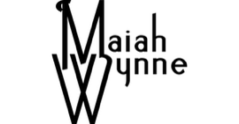


www.kscopemusic.com

