

**TWO SIDES OF SHAD: “K.I.S.S.” AND “ISLANDS” HIGHLIGHT NEW ALBUM VIBES**

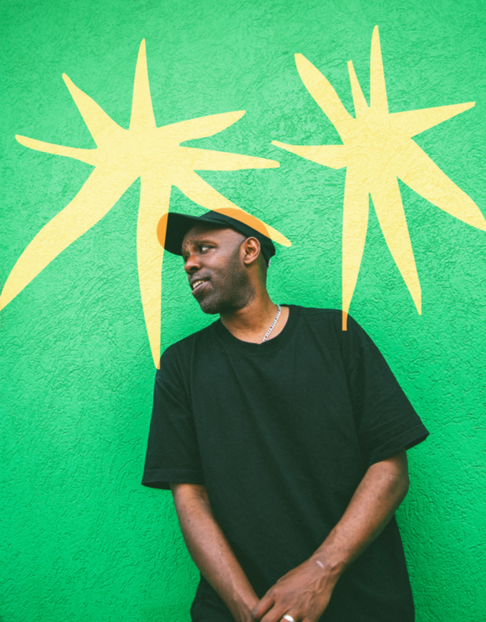

Photo Credit: Justin Broadbent

**TWO NEW TRACKS FROM**  
**THE ACCLAIMED CANADIAN HIP HOP ARTIST AHEAD OF HIS HIGHLY ANTICIPATED ALBUM START ANEW**

**ANNOUNCING 2026 CANADIAN TOUR DATES**

Canadian hip hop veteran **Shad** returns with a bold new double-single: **“K.I.S.S.”** and **“Islands.”** These tracks offer a glimpse into his upcoming seventh studio album ***Start Anew***, due **October 31, 2025** via **Secret City Records**.

[**Listen to “K.I.S.S.” and “Islands” here.**](https://m.secretcityrecords.com/kissandislands)

Reflecting on this milestone **Shad** says: *With these songs and the new album, I wanted to embrace simplicity and also community — things that feel more important to me than ever after twenty years in this game. “K.I.S.S.” is about having fun and moving forward, while ‘Islands’ is inspired by a concept/book a friend told me about called "Islands Of Sanity", basically about building hopeful futures in times of upheaval and disintegration*.

**“K.I.S.S.”** delivers a playful, upbeat vibe with the mantra “Keep it simple stupid / This is music / Give your two cents / Then keep it moving.” The track is produced by **Dom Dias**, who has crafted beats for **Snotty Nose Rez Kids**, **Cartel Madras**, and **Just John**, as well as **“Body (No Reason)”** on **Shad**’s previous album ***TAO***.

On the introspective **“Islands,”** Shad explores the concept of “Islands of Sanity,” meaning communities that model alternative ways of living through crisis. The production is handled by Windsor’s Datsunn, a multi-talented producer, drummer, and singer with strong ties to the jazz scene and recent tours with Carrtoons and Keifer.

Both songs highlight the balance of optimism and social consciousness that defines *Start Anew*. The album features collaborations with Toronto’s **Jon Kabongo**, **Raz Fresco**, **Phoenix Pagliacci**, Queens underground stalwart **Homeboy Sandman**, Atlanta’s **Chantae Cann**, and more.

[**Pre-save *Start Anew* here**](https://found.ee/startanew)**.**  
[**Pre-order the *Start*** ***Anew* vinyl here**.](https://found.ee/boutique-shad)

**“Bars and BBQs”** was featured on Okayplayer’s “The Listening” and VIBE’s “New Music Friday,” added to the CABBAGES Official Playlist, and spins on stations like KXRY, KEXP, WBTV, WERU, WPRK, CBC Afterdark, CBC Music’s The Block, CJLO, and CJSW. Other outlets putting a spotlight on the song include CBC News, CBC Music’s “Songs You Need To Hear,” Exclaim!, Hip Hop Canada, Live In Limbo, 3am Revelations, and V13.

Musically, **Shad** took a more straightforward approach on this album, drawing on playful soulfulness reminiscent of his early work, while incorporating experimental sounds sampled from his own unreleased archives ranging from house to psychedelic pop. This melding of vintage vibes and studio experimentation creates a sound that is both familiar and refreshingly accessible. As **Shad** puts it, “I wanted to make something kind of simple and easy on the ears and very listenable.”

This year marks 20 years of **Shad** in music, a milestone celebrating two decades of artistic growth, impact, and innovation. Known for his sharp wit, socially conscious lyricism, and versatile sound, Shad (Shadrach Kabango) continues to share an inspired message with ***Start Anew*** - a project about embracing change, facing loss, and moving into uncertainty with hope. Shad sees this album as the conclusion of a trilogy of socially conscious works including 2018’s ***A Short Story About a War*** and 2021’s ***TAO***, his final comment in a years-long exploration of what underlies the tensions of our current age.

**Start Anew** will officially release on **Friday October 31, 2025,** marking another milestone in Shad’s ongoing journey of evolution and renewal. Fans can catch Shad one night before the big Polaris Concert & Award Ceremony on September 15, where the 5x Short-Lister will play and unpack a set of easy listening gems he loves, live at Loveless Cafe in Toronto. The Canadian rapper will also hit the road early next year for his first run of Canadian dates in 2026, kicking off January 17 at Vancouver’s Hollywood Theatre before making stops at Blizzard Festival in Rossland on January 22, Calgary’s Commonwealth Bar & Stage on January 23, and Winterruption Festival in Edmonton on January 24. The tour continues into February with shows at Guelph’s Sonic Hall on February 6 and wraps in Hamilton on February 7 at Bridgeworks.

**SHAD | 2026 CANADIAN TOUR DATES**

Saturday January 17 - Vancouver - Hollywood Theatre

Thursday January 22 - Rossland - Rossland Miners’ Hall (Blizzard Festival)

Friday January 23 - Calgary - Commonwealth Bar & Stage

Saturday January 24 - Edmonton - Rocky Mountain Icehouse (Winterruption Festival)

Friday February 6 - Guelph - Sonic Hall

Saturday February 7 - Hamilton - Bridgeworks

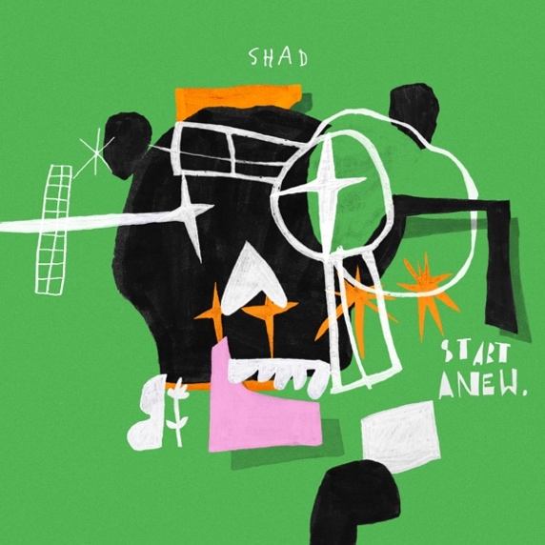

***Start Anew* tracklist:**

1. Intro
2. Slanted
3. Happiness
4. Rain
5. K.I.S.S
6. Islands
7. Bars and BBQs
8. Discern
9. Look Pt 1
10. Look Pt 2
11. Don’t
12. Sacrifice
13. Fear of Death

**Shad Online**  
[Website](http://www.shadk.com/) | [Facebook](https://www.facebook.com/shadk/) | [TikTok](https://www.tiktok.com/@shadkmusic) | [Instagram](https://www.instagram.com/shadkmusic/) | [Youtube](https://www.youtube.com/shadkmusic) | [Twitter](https://twitter.com/shadkmusic)

**Secret City Records Online**  
 [Website](http://secretcityrecords.com/) | [Facebook](http://facebook.com/secretcityrecords) | [Instagram](http://instagram.com/secretcityrecords) | [Twitter](http://twitter.com/secretcityrcrds) | [TikTok](https://www.tiktok.com/@secretcityrecords)