

**Canadian Songwriters Hall of Fame Unveils 2025 LEGENDS Induction Series in Toronto and Montréal**

*Legendary Songwriters Andy Kim, Jane Siberry, Ian Thomas, Triumph, and Gino Vannelli to be Inducted in Toronto; François Cousineau, Kate & Anna McGarrigle, Michel Pagliaro, and Florent Vollant in Montreal*

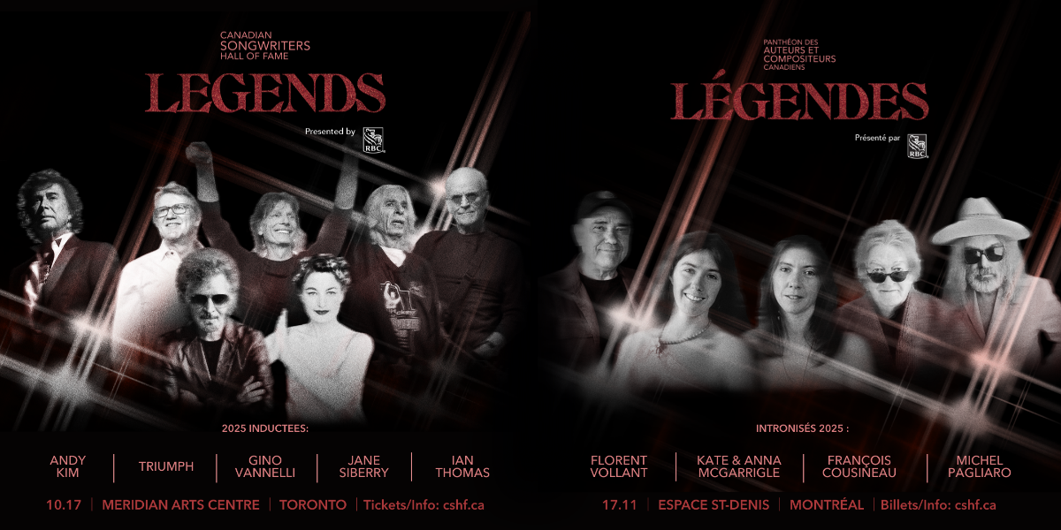

|  |  |
| --- | --- |
| **Legends Series Toronto**  October 17, 2025 at 8:00 p.m. Lyric Theatre, Meridian Arts Centre 5040 Yonge Street | **Legends Series Montreal** November 17, 2025 at 8:00 p.m. Studio Cabaret, Espace St-Denis 1594 Saint-Denis Street |

**For Immediate Release – Tuesday, August 26, 2025, Toronto (ON)** — The Canadian Songwriters Hall of Fame (CSHF) is proud to announce *LEGENDS* presented by RBC — a 2025 series of induction events honouring nine iconic songwriters whose music has helped define Canada’s cultural landscape and shape the international soundscape for generations. This year’s inductees—**François Cousineau, Andy Kim, Kate & Anna McGarrigle, Michel Pagliaro, Jane Siberry, Ian Thomas, Triumph, Gino Vannelli, Florent Vollant**—represent a rich cross-section of Canadian music history, from chart-topping hits and folk traditions to rock anthems, studio cabaret, and groundbreaking francophone and Indigenous voices. Though their styles and languages vary, they are united by a shared legacy of creativity, cultural contribution, and storytelling that resonates far beyond the stage. Together, they exemplify the depth, diversity, and enduring impact of Canadian songwriting.

“This year’s Legends embody the values that define Canadian songwriting: artistic courage, cultural contribution, and storytelling that transcends genre and language,” says **Nick Fedor**, **Executive Director, Canadian Songwriters Hall of Fame**. “The Legends Series is more than an awards show—it’s a national stage for celebrating legacy, inspiring the next generation, and elevating the role of the songwriter in our cultural identity.”

Following the celebrations in Toronto and Montreal, the Class of 2025 inductees will be indelibly honoured at the CSHF’s permanent location at [Studio Bell](https://www.studiobell.ca/), home of the National Music Centre in Calgary, which features exclusive artifacts and one-of-a-kind memorabilia celebrating Canada’s greatest songwriters and inductees.

Building on its successful 2023 debut, LEGENDS returns to celebrate generational songs and songwriters with inductions into the Class of 2025. These intimate, exclusive events will once again honour Canada’s rich musical legacy in two of the country’s most iconic music cities. This year’s celebrations will take place at the **Meridian Arts Centre** in **Toronto** on **October 17** and **Espace St-Denis** in **Montreal** on **November 17**.

Each evening will feature live tributes and special guest performances from emerging and sought-after artists, while also shining a spotlight on the **Breakthrough Songwriter Award**—an initiative that recognizes and amplifies Canada’s most exciting emerging songwriting talent. This year’s nominees will be announced soon, joining past honourees such as **Jessie Reyez**, **Mustafa**, **Lowell**, and **Charlotte Cardin**.

The Canadian Songwriters Hall of Fame continues to invest in the future of Canadian music through initiatives like the Legends Series, Song & Score Day, and special Hall of Fame Masterclasses presented by RBC—each designed to connect generations of music creators. Taking place in tandem with the Legends Induction events, these programs feature educational sessions, artist panels, and rare opportunities to engage with iconic and emerging songwriters. Full details will be announced soon.

With special thanks to our sponsors and partners: RBC, SOCAN, Hargraft Insurance, CMRRA, Anthem Music Group, the Songwriters Association of Canada, the Lewitt Family Foundation, the Slaight Family Foundation, and e=mc² for their invaluable support in helping us celebrate and champion Canadian songwriters through these meaningful programs and events.

Tickets for the induction event at **Toronto’s Meridian Arts Centre on October 17** go on sale **TODAY** at 1**0:00 a.m. ET** via **Ticketmaster** [**HERE**](https://www.ticketmaster.ca/event/10006315E5255A35). Tickets for the **Montreal event** go on sale on **August 28** at **10:00 a.m. ET** via **Espace St-Denis** [**HERE**](https://espacestdenis.com/achat-de-billets-espacest-denis/).

**For more information, please visit:** [**www.cshf.ca**](http://www.cshf.ca).

**Inductees – Legends Series Toronto (October 17)**

* **Andy Kim** – The composer of *Sugar, Sugar* and *Rock Me Gently*, Kim built a career on fearlessness and reinvention, from Brill Building beginnings to Canadian icon. [Read Bio](https://drive.google.com/drive/folders/1_EHkV9wrQXszxNWoTDlTAzPMHAVP0bQa) »
* **Ian Thomas** – With hits like *Painted Ladies* and *The Runner*, Thomas is a genre-spanning craftsman who’s written for America, Santana, and Bette Midler. [Read Bio](https://drive.google.com/drive/folders/18SM7h4GChnS7FclwZ3JV3LvMlCicpU34) »
* **Triumph** – The hard-rock trio from Mississauga defined Canadian arena rock with *Magic Power* and *Fight the Good Fight* and redefined the concert experience. [Read Bio](https://drive.google.com/drive/folders/1z04rSmxvUYLtnOuTOLh4K6Zzc7t12h7_) »
* **Jane Siberry** – A poet of song, Siberry has defied category for four decades with a catalogue spanning the mystical and the intimate. Read Bio »
* **Gino Vannelli** – With his blend of soul, jazz, and pop, Vannelli earned international acclaim and broke barriers as a genre-defying singer-songwriter. [Read Bio](https://drive.google.com/drive/folders/1YzVhY09MNQoDSQ6c5K3FdM83JF7_ToQS) »

**Inductees – Legends Series Montreal (November 17)**

* **Kate & Anna McGarrigle** – Beloved for their vocal harmonies and timeless songwriting, the McGarrigles brought Québécois folk to international acclaim. [Read Bio](https://drive.google.com/drive/folders/1WFSnwsTdt_N9Z5e-hCWNg0F73lklTwsS) »
* **François Cousineau** – A towering figure in Quebec culture, Cousineau’s work spans chanson, cinema, theatre, and television, shaping the province’s sound for over 50 years. [Read Bio](https://drive.google.com/drive/folders/1UOvjxjxLAEkghGJ9OfY-2LhgppUPCoiu) »
* **Michel Pagliaro** – A pioneer of bilingual rock, Pagliaro broke ground with gold records in both French and English and remains a force of raw poetic power. [Read Bio](https://drive.google.com/drive/folders/1KKv38U_BjGhQIF2rBflgfZIMbiDKdTAS) »
* **Florent Vollant** – A trailblazer in Indigenous music, Vollant’s solo work and Kashtin legacy continue to uplift Innu language and voices across generations. [Read Bio](https://drive.google.com/drive/folders/1-n77w0ScUAy_8UhEQj_iKiudTf9kIFEx) »

**ABOUT CANADIAN SONGWRITERS HALL OF FAME (CSHF)**

The Canadian Songwriters Hall of Fame (CSHF) is a national and non-profit organization that is dedicated to honouring and celebrating Canadian songwriters and those who’ve dedicated their lives to the legacy of music. The CSHF also works to educate the public about these achievements and to foster the next generation of songwriters through year-round initiatives and events. In December of 2011, SOCAN (the Society of Composers, Authors and Music Publishers of Canada) acquired the CSHF; however, the Hall of Fame continues to be run as a separate organization and is guided by its own Board of Directors, comprised of both Anglophone and Francophone music creators and publishers, as well as representation from the record industry. The CSHF’s mandate aligns with SOCAN’s objectives as a songwriter and publisher membership-based organization. www.cshf.ca

**Media Contacts:**

|  |  |
| --- | --- |
| **TORONTO** **Victoria Lord Victoria Lord PR** Email: victoria@vlpr.com Phone: 647-519-8577 [www.vlpr.com](http://www.vlpr.com) | **MONTREAL** **Simon Fauteux** **SIX media marketing Inc.** Email: simon@sixmedia.ca Phone: 514-972-4584 [www.sixmedia.ca](http://www.sixmedia.ca) |