CARRIE UNDERWOOD UNITES WITH PAPA ROACH TO SING “LEAVE A LIGHT ON (TALK AWAY THE DARK)”, OUT FRIDAY AUGUST 2nd

ARTISTS WILL BE DONATING ROYALTIES IN PERPETUITY TO THE AMERICAN FOUNDATION FOR SUICIDE PREVENTION


Jacoby Shaddix and Carrie Underwood – Image Downloadable HERE, Credit: Bryson Roatch

July 31, 2024 (Los Angeles, CA) 8-time Grammy Award winner Carrie Underwood unites with Rock icons Papa Roach on a new recording of their multi-format hit single “Leave A Light On (Talk Away The Dark)”, out Friday August 2nd. The dynamic duet was recorded in Nashville, Tennessee, and continues the mission of the California band to raise awareness for suicide prevention and mental health awareness, alongside partner organization(s) the American Foundation for Suicide Prevention (AFSP), who will receive royalties generated from both artists from the song, in perpetuity. The release will also raise awareness for the 988 Suicide & Crisis Lifeline in the United States and Canada.

“We were humbled that Carrie was open to our mission, and hearing the power of Carrie’s voice in that recording session we were blown away” said frontman Jacoby Shaddix. “Not only is her vocal ability unequaled, but the impact of her voice brings a new meaning to our cause and will help people all over the globe. It’s an honor to have a “Rock Star” bring life to this track with us.”

“I’m such a huge fan of Jacoby and Papa Roach and was honored to be invited to record ‘Leave A Light On’ with them,” says Underwood. “It’s a beautiful song and the message behind it and the band’s mission to shine a light on suicide prevention and mental health awareness has never been more important.”

“Leave A Light On”, a band favorite, was first performed live last year with Shinedown and Spiritbox. In each city, including Nashville where Papa Roach fan Carrie Underwood was in attendance, the song was preceded by an emotional video PSA delivered by frontman Jacoby Shaddix, who pledged a donation to the AFSP on behalf of each city’s attendees, culminating in a $155,000 donation at the end of the tour.

The accomplishment motivated the band to commit even further by re-naming the single as “Leave A Light On (Talk Away The Dark)”, in conjunction with the AFSP’s “Talk Away The Dark” campaign, and pledged a perpetual royalty from the song’s use, in any manner, to the AFSP, continuing their mission to save lives and bring hope to those affected by suicide. The compelling song has connected with audiences globally and became the band’s 12th #1 and 26th Top-10 hit reaching #1 at Rock and Top-10 at Alternative in the US. The band’s efforts in raising money for the AFSP have not ceased and are now estimated to be over $250,000 - and growing.

"Papa Roach's "Leave a Light On/Talk Away the Dark" has tapped into a cultural moment in which people are eager and ready for the message the song contains: that we all go through difficult times and that we can all be there for each other. We want to thank Carrie Underwood for joining with Papa Roach to record this new, inspiring duet version, which will reach even more fans and connect them to AFSP’s Talk Away the Dark campaign," said American Foundation for Suicide Prevention CEO Bob Gebbia. "We are also incredibly grateful to Papa Roach and Carrie Underwood for their commitment to providing those struggling with their mental health information and resources that can help. These amazing artists are educating the public about the importance of taking care of our mental health, and they are generously supporting the AFSP's mission of saving lives and bringing hope to those affected by suicide."

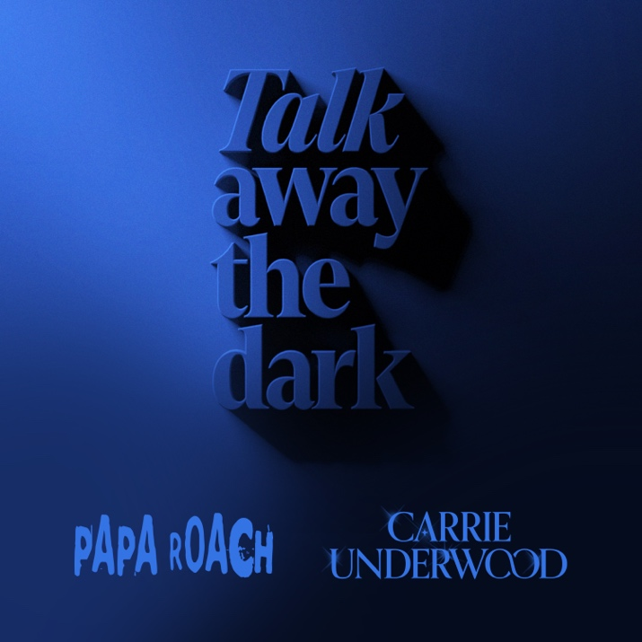

••••

ABOUT PAPA ROACH
Papa Roach are two-time GRAMMY-nominated, Platinum-selling leaders in Alternative Hard Rock music, who in 2025 will celebrate the 25th Anniversary of their iconic album INFEST. Papa Roach are not unfamiliar with calling attention to Mental Health and have been doing so since the seminal release of their first hit-single “Last Resort.” Since then, the band has gone on to create 10 studio albums, their most recent Ego Trip on their own label New Noize Records. Ego Trip has garnered over 450 million global streams to date and has produced four #1 singles bringing the band’s total to 26 career Top-10 hits, and 12 career #1’s. Papa Roach recently announced their headline “Rise of the Roach” Arena tour for 2025 in select cities throughout Europe, including London’s famed Wembley Arena.

ABOUT CARRIE UNDERWOOD
Carrie Underwood is a true multi-format, multi-media superstar, spanning achievements in music, television, film, and as a New York Times bestselling author and successful entrepreneur. Carrie has sold more than 85 million records worldwide, recorded 28 #1 singles (14 of which she co-wrote), is the most-awarded female country artist for singles in RIAA history, and has seven albums that are certified Multi-Platinum or Platinum by the RIAA, with over 72 million total RIAA certifications to date, all while continuing to sell out arena tours across North America and the UK. Carrie has won over 100 major awards including 8 GRAMMY® Awards, 16 ACM Awards including three for Entertainer of the Year (the first female in history to win twice and the only female ever to win three times), 25 CMT Music Awards (holding the record for the most award wins ever for the show), 7 CMA Awards, 17 American Music Awards, and10 People’s Choice Awards. She has been a proud member of the Grand Ole Opry since 2008 and was honored with a star on the Hollywood Walk of Fame in 2018. Her ongoing REFLECTION: The Las Vegas Residency continues to play to packed houses and has been extended into 2025. She recently celebrated the one-year anniversary of her exclusive year-round SiriusXM channel, CARRIE’S COUNTRY.

ABOUT AFSP
The American Foundation for Suicide Prevention is dedicated to saving lives and bringing hope to those affected by suicide, including those who have experienced a loss. AFSP creates a culture that’s smart about mental health through public education and community programs, develops suicide prevention through research and advocacy, and provides support for those affected by suicide. Led by CEO Robert Gebbia and headquartered in New York, with a public policy office in Washington, D.C., AFSP has local chapters in all 50 states, D.C. and Puerto Rico, with programs and events nationwide. Learn more about AFSP in its latest Annual Report and join the conversation on suicide prevention by following AFSP on Facebook, Twitter, Instagram, YouTube, LinkedIn and TikTok.

ABOUT THE 988 SUICIDE & CRISIS LIFELINE
(formerly the National Suicide Prevention Lifeline)
Funded by SAMHSA and administered by Vibrant Emotional Health, the 988 Suicide & Crisis Lifeline (988 Lifeline) is a leader in suicide prevention and mental health crisis care. The 988 Lifeline provides free and confidential emotional support and crisis counseling to people in suicidal crisis or emotional distress 24 hours a day, 7 days a week, across the United States. Callers who follow the “press 1” prompt are connected to the Veterans Crisis Line. A Spanish Language line is available by pressing 2 when calling 9-8-8, and more than 240 languages are supported through a Tele-Interpreters service. The Lifeline is comprised of a national network of more than 200 local crisis centers, uniting local resources with national best practices. Since its inception in 2005, the Lifeline has engaged in innovative public messaging, development of best practices in mental health, creative partnerships, and more to improve crisis services and advance suicide prevention for all. 988lifeline.org

For more information on Papa Roach, Visit / Follow / Subscribe:
Instagram | Facebook | Twitter | YouTube | TikTok| Spotify

