Due For Release 16th June 2023 via BMG / Dark Horse Records
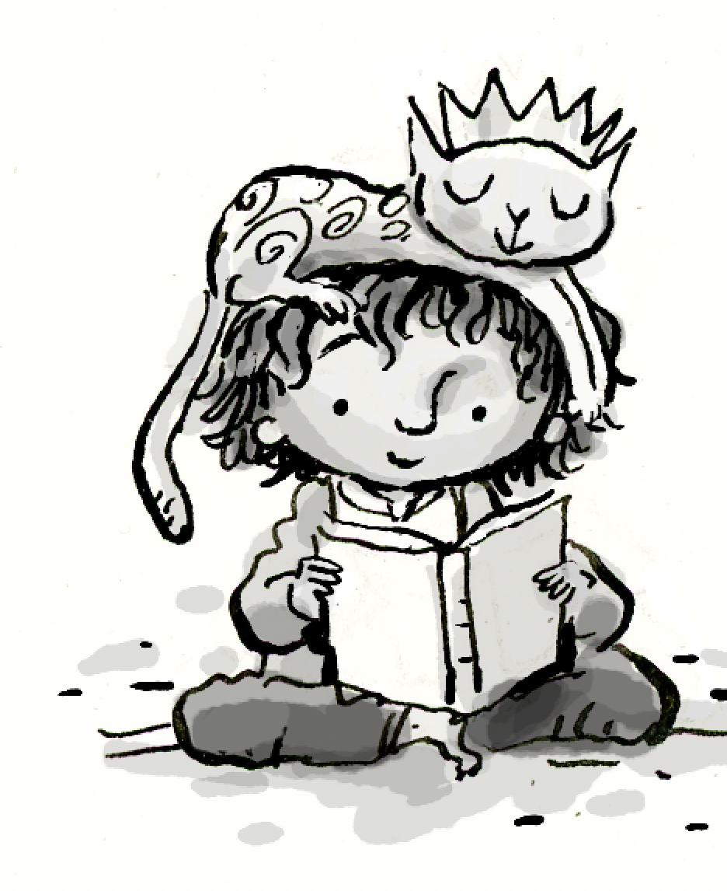

“ ‘Cause it’s not for us to say what life will be…”
– Yusuf / Cat Stevens

At a time of accelerated climate instability, earthquakes, wars and new global tensions, Yusuf / Cat Stevens invites you to take a deep breath and revive your hopes for a world which embraces the lost lands of truisms and stainless youth; a world we all, at one time or another, lived and danced in. His songs have a breathtaking ability to vividly bring us back to a time when “… all things were tall, and our friends were small”. Yusuf’s music and words don’t ask us to intellectualise, but simply listen and get immersed in more humane stories - where happy endings can possibly happen.

King of a Land is Yusuf / Cat Stevens’ seventeenth album. Containing 12 brand new songs. The title track retells the story found in the beautiful illustration bedecking the cover, of a small boy (and his playful ginger cat) who imagines what good he would do if he were king of a land - a place of should-be or “Woodbee”. Childlike faith and dreams are brought back into touching distance of our aural/audio sensualities as he takes us on a new journey. His voice, words and stunning melodies draw you in from the start, leaving you waiting at the gates of a much nicer world than the one we presently inhabit.

It’s been nearly 60 years since that 17 year old ‘Cat’ burst upon the pop scene with hits such as 'Matthew and Son' and 'I’m Gonna Get Me a Gun'. Writing some of the most memorable hits like 'The First Cut Is The Deepest' and 'Here Comes My Baby'. This was the “Swinging 60’s” where pop artists came and went. Some of those chart hits were by solo singer/songwriter artists such as Bob Dylan, Donovan, Joni Mitchell and Paul Simon, precious few of which remain as creatively active today. It was a young Cat Stevens that had his first studio album Matthew and Son, released on Decca’s new exciting Deram Label. This was not a one off album but the start of a long musical adventure that unbelievably continues right up to the present. The hunger and drive to write, record and entertain, is remarkably still there. It hasn’t waned.

King of a Land is an epic piece of work, timeless, in more ways than one. It’s been more than a decade in the making, with early sessions stretching back to 2011 at Berlin’s Hansa Studios (the setting for key albums by David Bowie and U2)… From there, the recording locations moved through the years from ICP Studios in Brussels to La Fabrique in Provence, South of France. Additional overdubs and a 60-piece orchestra were recorded in Air and Angel studios in London. Some key work was originally recorded in Yusuf’s own garage-based home studio in Dubai he calls “Dubville”.

“Most of the songs started with me playing and recording everything at home in the garage - it’s as close as you can get to being inside my head,” Yusuf says.
Overseeing the sonically creative process was Yusuf’s long-term (since Mona Bone Jakon) producer, and later co-producer, ex-Yardbird, Paul Samwell-Smith. In choosing the musicians for the album, Paul and Yusuf assembled a top-flight team to embellish the songs, including bass-player Bruce Lynch (who first worked with him on 1974’s Buddha And The Chocolate Box), keyboard-player Peter Vettese (Jethro Tull, Bee Gees, Simple Minds) and drummer Russ Kunkel (Joni Mitchell, Carol King, James Taylor, CSN&Y), as well as his familiar two-piece band of Kwame Yeboah and Eric Appapoulay.

Talking about his co-producer, “Paul’s brilliant; he’s a great delineator of style,” says Yusuf, “understanding me, and where I want to go. He lets me go there, and sometimes tails me down and challenges me. But most times, Paul would be analysing what I want to do, and giving me the space to do it.”
The album is full of extraordinary surprises, ‘Pagan Run’ arrives with glorious and unexpected hard-rock intensity. “Picking up the guitar and finding that riff, that’s how that song began, and then it just developed. The lyrics are a replay of the other-worldly race I’ve been on,” he says. “How messed up I was, trying to work out the riddles in life, what it all means. I was in a seriously ignorant condition, extremely superstitious and scared to death about unseen forces, things which can suddenly jump out and hurt you - or worse. In the end I got to know the Higher Power, which has control over everything.”

Yusuf’s faith is vividly expressed on the album in the delicate acoustic ballad ‘He Is True’, through to the driving Phil Spector-goes-gospel vibe of ‘Highness’, and the ornate, atmospheric ‘Son Of Mary’, which impressively tells the story of Jesus and Mary in concise verses.

“That song summarises what I think is one of the most complex stories of any figure in religious and spiritual history,” Yusuf explains.

Elsewhere, ‘The Boy Who Knew How To Climb Walls’ takes the listener to pre-partitioned Palestine, in a vivid tale of two close friends, growing up before war erupted – one of whom ends up burying the other. The song closes with the haunting, repeated refrain, “I can see him now floating on the air”.

The album’s fantastic artwork is provided by the award winning Canadian children’s illustrator Peter H. Reynolds, continuing a collaboration with Yusuf that began with the NY Times best selling Peace Train picture book in 2021. As well as the sumptuous cover art, Peter has created illustrations for each of the songs which accompany the album’s lyrics in the album booklet. Because of the success of that collaboration, Yusuf was eager to get Peter involved in working with him on King.

“I’ve always loved cartoons, when I saw Peter's style, I loved it. He’s illustrated most of the songs as well as the cover. One of my favourites, ‘How Good It Feels’, cites where a child is being lifted by this gentle giant’s hand, "I know what it’s like when a hand comes down and lifts me off the ground." My specific memory for that one was my childhood, I was roaming around Battersea Funfair and suddenly lost sight of my mother. I was alone and crying, and then suddenly she appeared out of the crowd and picked me up.”
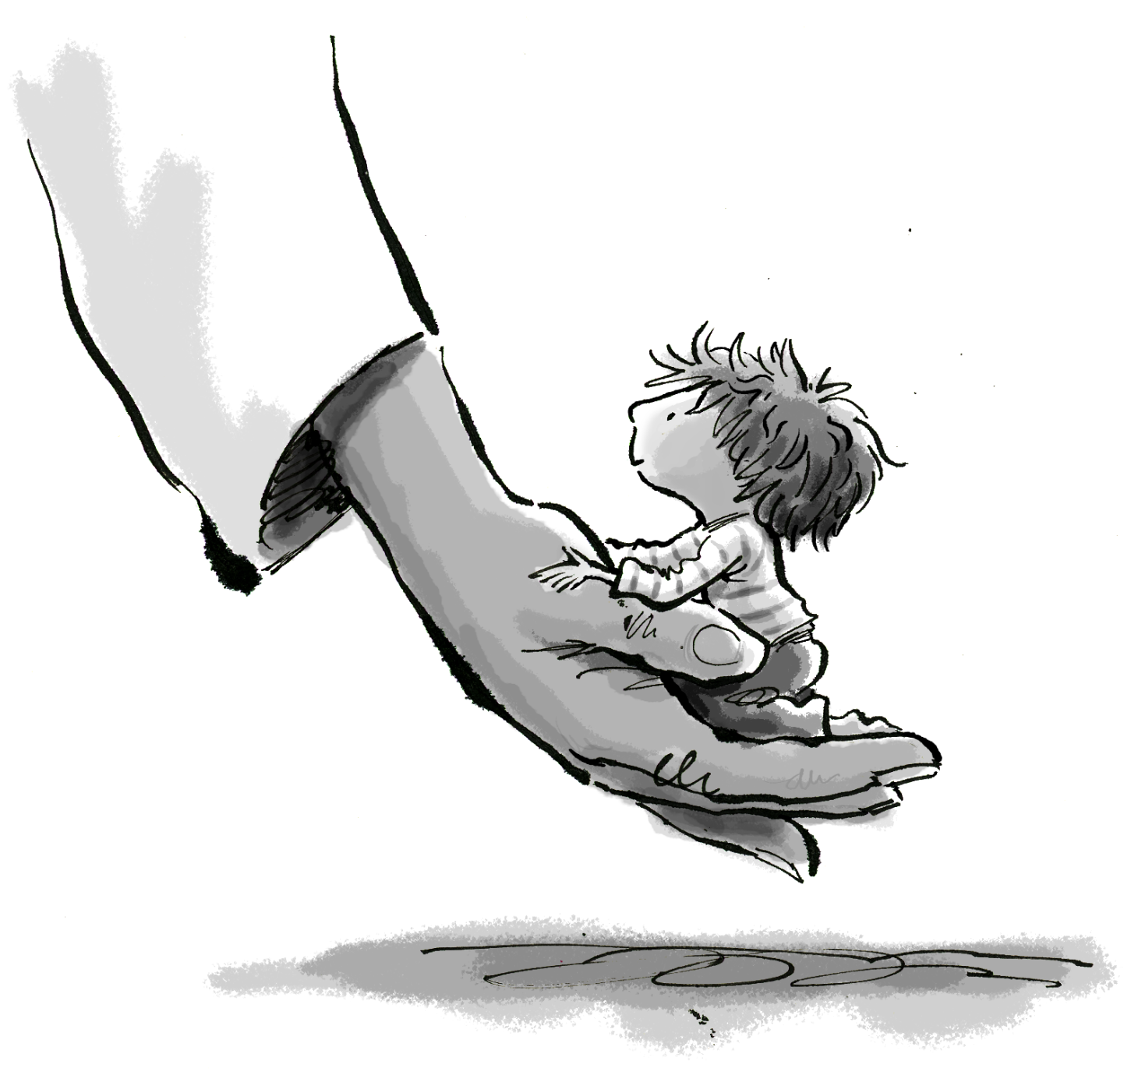

“One of the things that I loved doing recently, through re-releasing classic albums like Tea for the Tillerman and Teaser and the Firecat, was getting involved in designing and developing visuals for the boxsets. I kind of fell into that kiddy-world again, which I’ve done again very, very clearly on the cover of this album.

In other parts of King of A Land, there’s a clear frustration with the state of the modern world: ‘Train On A Hill’, and its stunningly, beautiful classic arrangement, depicts Yusuf’s thwarted ‘Peace Train’, chained and immobile, “… ‘cause the earth just isn’t fair.”

Another ear-catcher with its rolling, Travelling Wilburys-styled groove, ‘All Nights, All Days’ takes on an Americana country feel.

“I like to take on different genres, ‘All Nights…’ just felt naturally born for that - but it could easily have ended up somewhere else, ha ha!” The lyrics rail against how “the rich tax the poor” and, with wry humour, suggests to “lock those leaders in London Zoo”.

“That’s where a lot of them belong, let’s face it,” Yusuf laughs. “The only way that we can get on in peace is to get rid of most of them. Not all, perhaps. But most …”

Interestingly, the final mix down of King Of A Land, took place in Henley-on-Thames, at George Harrison’s private studio lodged in his former home, Friar Park. “We were very privileged to be in Friar Park,” says Yusuf, “and to be one of the first outsiders to enter that control room and mix an album. George Harrison has been an immense influence on me spiritually, from the very beginning. He pioneered certain thoughts and ideas, which stretched way east, and that was very important. So, if you listen to some of these songs on this album, you’ll hear a kind of spirit of George.” The album, by no small coincidence is also released through Dark Horse Records, Harrison’s own label run by his son Dhani.

Meanwhile, the dreamy pop of ‘Another Night In The Rain’ (with its elements of Peter Gabriel and The Beatles) cuts a picture of a hapless figure out in the streets, getting soaked, while grimly contemplating his prospects. “It’s a young dude, who is totally disappointed with himself, unsure of what he can grab from this life,” a kind of urban tragedy that enforces common youthful insecurities. “after I wrote it,” he adds, “I noticed there’s another voice in there, which is graciously optimistic, offering the youngster ideas of how he can make his way through the angst of teenage life - symbolised by rain. So, it’s not ‘Father And Son’, but it’s very similar in the way that there’s a discussion going on.”

The album’s quintessential track, ‘How Good It Feels’, builds from quiet acoustic guitar arpeggios to a full-bodied, Tchaikovsky-inspired orchestration, arranged by Nick Ingham and recorded at AIR Studios. The song actually has its roots in a melody that first came to Yusuf back in 1968. “This is my opus,” he says. “It’s taken me this long to write this song. I’ve always been inspired by classical composers. There’s an extract from Swan Lake which really gave me the inspiration for the melody, fifty-seven years ago. I decided to be very honest about it, so you see me bring Tchaikovsky’s theme into it, twice.

The final track is one of the most powerfully catchy songs on the album, ‘Take The World Apart’, chosen to head the train of singles in the build-up to the launch of King of a Land, scheduled for June 2023. An accompanying animated lyric video, created by Peter Reynolds, is destined to charm. Painting a delightful entrance to the powerfully childlike theme of the album, it matches the joy and optimism Yusuf’s music naturally evokes.

Yusuf / Cat Stevens has drawn on all his years as a composer and musical icon; a prince of poetical storytelling. He has assembled a mosaic of musical delights, equally as transportive a listening experience as any of his previous classics. This album is Yusuf at the height of his creative powers. Unbound by genre, there is no need to consider whether the musical style is pop, country, rock, folk, spiritual or classical. It’s all there to power the lyrics straight to your heart. Close your eyes, shut out the world for 42 minutes and get ready for your meeting with King of a Land.

